**Project Report**

1. **Introduction**
   1. **Overview**

Keerthi Sweets Manufacturer and Trader of Sweets, relies on Zoho Books to manage their inventory, handle purchase orders, and generate invoices for their customers. They can track stock levels, manage supplier payments, and generate financial reports. Zoho Books helps them streamline their wholesale operations and optimize inventory management.

Keerthi Sweets is a renowned manufacturer and trader of delectable sweets, catering to both wholesale and retail customers. With a rich heritage spanning several decades, Keerthi Sweets has earned a reputation for its commitment to quality, authenticity, and customer satisfaction. Specializing in a wide variety of traditional and innovative sweets, they combine traditional recipes with modern techniques to create flavors that tantalize taste buds.

Keerthi Sweets is a Private Limited company also registered under GST in Tamil Nadu. Keerthi Sweets is a Manufacturer and trader of various sweets in wholesale and retail, it has a wide range of customers (B2B & B2C) all over the state and it procures raw material from various suppliers in the state. It operates at a Gross Profit margin of 50%.

* 1. **Purpose**

The purpose of this project is to leverage the capabilities of Zoho Books to enhance the financial and operational aspects of Keerthi Sweets. The project's objectives include improving efficiency, compliance, and customer service while optimizing business processes for long-term success.

1. **Problem Definition & Design Thinking**
   1. **Empathy Map**

* 1. **Ideation & Brainstorming Map**

1. **Result**

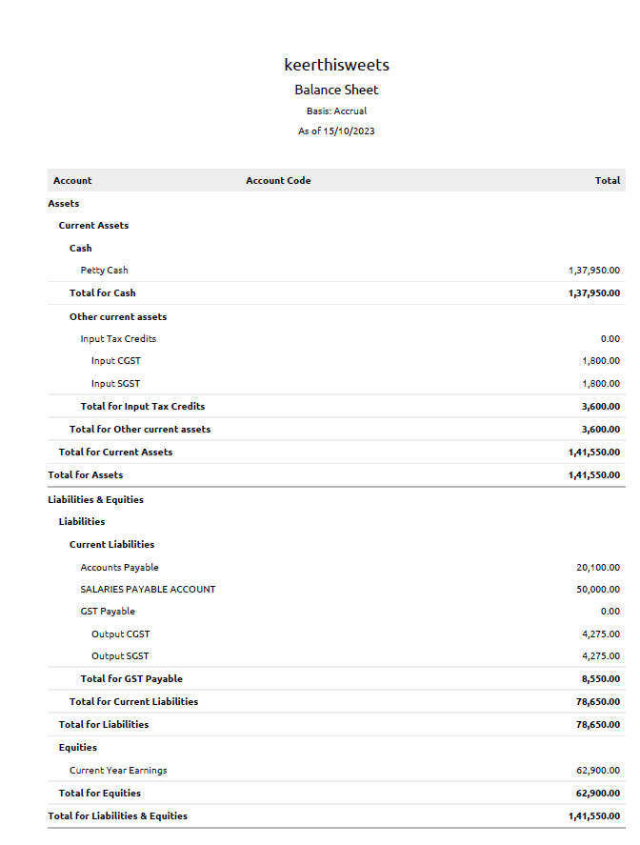

1. **Advantages & Disadvantages**
   1. **Advantages**

User-Friendly Interface: Zoho Books is known for its intuitive and user-friendly interface, making it accessible to users with varying levels of accounting and financial expertise.

Cloud-Based Accessibility: As a cloud-based platform, Zoho Books allows users to access their financial data from anywhere with an internet connection. This is especially valuable for remote work and collaboration.

Scalability: Zoho Books can accommodate the needs of small businesses and scale up to meet the requirements of larger enterprises. This flexibility is ideal for companies as they grow.

Comprehensive Accounting: Zoho Books offers a wide range of accounting features, including invoicing, expense tracking, bank reconciliation, and financial reporting. This comprehensive functionality allows businesses to manage their finances effectively.

* 1. **Disadvantages**

Limited International Tax Support: Zoho Books is designed for specific countries and may not provide comprehensive support for international tax systems. This can be a limitation for businesses operating globally.

Complex Businesses May Require Add-Ons: For complex business structures or industries, Zoho Books may require additional add-ons or integrations to meet specific needs, potentially increasing the overall cost.

Payroll Features: Zoho Books' payroll capabilities may not be as robust as some dedicated payroll software solutions. This can be a limitation for businesses with complex payroll requirements.

Learning Curve: While Zoho Books is user-friendly, some users may still find a learning curve, especially if they are not familiar with accounting principles or software.

1. **Applications**

The name of our Sweet is:

Keerthi Sweets

This Sweetis located and applied in the following address:

Keerthi Sweets, South Street, Pandalgudi

Contact No:9081734256

Email ID:keerthisweets@gmail.com

1. **Conclusion**

Maintaining Zoho Books for Keerthi Sweets involves ongoing data entry, monitoring, and regular updates. By following these steps, you can streamline your inventory management, purchase order handling, and invoicing processes while ensuring accurate financial records and GST compliance.

1. **Future Scope**

The exact future developments of Zoho Books will depend on market trends, technological advancements, and the evolving needs of businesses. Businesses that use or consider using Zoho Books can look forward to a more feature-rich, efficient, and user-friendly accounting and financial management tool in the years to come.

1. A close-up of a receipt

   Description automatically generatedAPPENDIX

